CA2 Individual Report
Name | Pyae Phyo Maung
Student Id | P2535128
Class | DIT/FT/1B/03
Github Repository URL | Commits · ST0503-BED/bed-ca2-Luis-is-coder
Github Account ID | Luis-is-coder

For each competencies, find links to pull requests/commits/files that demonstrate the completion of the requirement. Replace each “?” with your Self Rating.
For Self Rating, you may rate yourself accordingly if you feel that you:
- Have little or no understanding. and did not attempt the requirement
- Have limited understanding of the specific competency
- Have basic understanding and only able to replicate examples from tutorials/practicals.
- Have adequate understanding and can extend from what you have learned to fulfil specifications.
- Have solid understanding in the specific competency, able work on the requirement without much references.
- Have excellent understanding and implemented the requirement according to latest industry guidelines, best practices and documentations.

Important
- You are require to provide for each competency:
  - A brief description
  - One or two of your best implementations with URL link to respective repository request/commits/files.
    - Below is an example of linking to specific script file
https://github.com/expressjs/express/blob/master/examples/static-files/index.js
  - The implementations may come from Section A or B.
- You are to ensure the hyperlink in this document works. Failure to do so will result in a 50% deduction of marks.
- You are to provide screenshots using POSTMAN to perform API test.

No. | Competencies | Describe What Was Done | Self Rating
1 | Backend Server | (How did you handles incoming requests, communicates with the database, and provides appropriate responses?)  Set up an Express server to handle incoming HTTP requests. Connected to the database to perform CRUD operations for user login and registration and others. Returned appropriate JSON responses with correct status codes based on the request outcome.  - Create Login Page and its functionality · ST0503-BED/bed-ca2-Luis-is-coder@604052e | 4/5
2 | Functionality | (Did your features implemented meets the specified requirements and fulfils its intended purpose?)  Implemented login functionality that authenticates users against the database and returns a token upon success. Built a register function that validates user input and creates new user accounts in the database. Both features meet the specified requirements and work as intended. User can also create challenges, track progress, earn and view points and interact with gamification features.  - Create Login Page and its functionality · ST0503-BED/bed-ca2-Luis-is-coder@604052e  -Build up the register function · ST0503-BED/bed-ca2-Luis-is-coder@e41c079 | 5/5
3 | Code Quality | (How did you organise your code to ensure maintainability, readability and adherence to coding best practices?)  Organized code using MVC architecture with separate routes, controllers, and models. Used consistent naming conventions and proper indentation throughout the project.  Please check the folder structure and codes inside. This is when I formatted the files to be in a standard format.  - Format document all the files · ST0503-BED/bed-ca2-Luis-is-coder@523e595 | 4/5
4 | Modularity | (How did you've organized your project to promote code reusability and maintainability?)  Separated concerns into distinct files — routes, middleware, models, and controllers. Reusable middleware functions like authentication verification are shared across multiple routes.  Please check the separation of files and folders.  Copy and Paste all the src files from CA1 · ST0503-BED/bed-ca2-Luis-is-coder@a58bf25 | 4/5
5 | Error Handling | (How did you manage errors, provide informative feedback, and handle exceptional situations?)  Used callback functions to handle errors operations. Checked for errors in callbacks and returned appropriate HTTP status codes (400, 401, 404, 500) with meaningful error messages to help with debugging and user feedback.  Please check the usage of callback.  - Add getPlanetsWithUserStatus in planetsModels.js to retrieve all th… · ST0503-BED/bed-ca2-Luis-is-coder@d912d35 | 4/5
6 | Documentation | (What was written for comments, readme and external documentation?)  Added inline comments to explain key logic in complex sections. Included a README with setup instructions.  Please Read README.  Commits · ST0503-BED/bed-ca2-Luis-is-coder | 4/5
7 | JWT for Authentication | (How did you generate, validate, and manage user tokens? How do you allow user to stay login for longer duration?)  Generated JWT tokens upon successful login with an expiration time. Validated tokens via middleware on protected routes to ensure only authenticated users can access them.  Add bcrypt middleware, jwt middleware and .env files · ST0503-BED/bed-ca2-Luis-is-coder@02782f8 | 4/5
8 | BCrypt for Password Hashing | (How did you securely store and validate user passwords? What did you do to balance between security and lightening server load?)  Used bcrypt to hash passwords before storing them in the database. On login, compared the input password against the stored hash using bcrypt.compare(). Used an appropriate salt round (e.g., 10) to balance security and server performance.  Add bcrypt middleware, jwt middleware and .env files · ST0503-BED/bed-ca2-Luis-is-coder@02782f8 | 4/5
9 | Frontend to Backend HTTP Requests | (How did you setup frontend communication with the backend?)  Used fetch API to send GET, POST, PUT, and DELETE requests from the frontend to the backend. Included JWT tokens in Authorization headers for protected endpoints.  - In fetching the planets, spaceshipskins and challenges, currently u… · ST0503-BED/bed-ca2-Luis-is-coder@e27dafe | 4/5
10 | HTML & CSS Proficiency | (Provide example of how you managed to create structured layouts and visually appealing styles)  Created structured, responsive layouts using semantic HTML elements and CSS flexbox/grid. Applied consistent styling for forms, buttons, and navigation to ensure a clean and user-friendly interface.  -In index.html, use the relative path for style.css and color.css · ST0503-BED/bed-ca2-Luis-is-coder@c72dc9d  - Add jump navigation so that the user can avoid scrolling in moving … · ST0503-BED/bed-ca2-Luis-is-coder@abf2f6e | 4/5
12 | JavaScript and DOM Manipulation | (How does your frontend utilise dynamic content and DOM manipulation?)  Used JavaScript to dynamically render content such as user data and form responses. Manipulated the DOM to show/hide elements, update text, and handle user interactions like form submissions and button clicks.  - Add the "Edit Profile" button and "Edit Profile Modal" in profile.html · ST0503-BED/bed-ca2-Luis-is-coder@58c8d86 | 4/5

Updated Entity Relationship Diagram
ERD
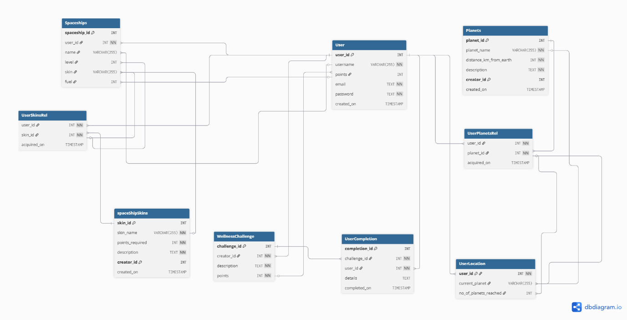
BED CA1 ERD - dbdiagram.io

Video Demo
No. | Label | Screenshot
 | Video Demo Youtube Link | https://youtu.be/IZDA_OcZY7M

Screenshots
No. | Label | Screenshot
 | POST /api/login  200 OK | 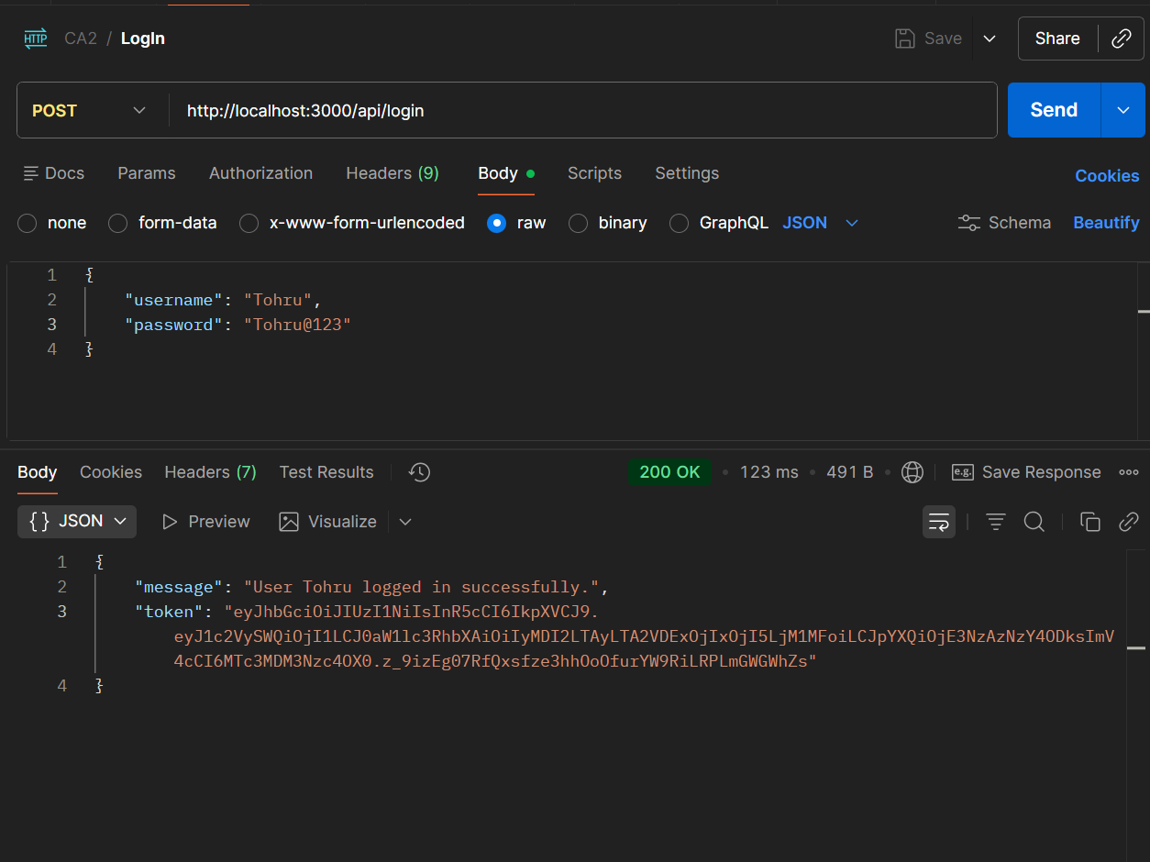
 | POST/api/login  401 unauthorized | 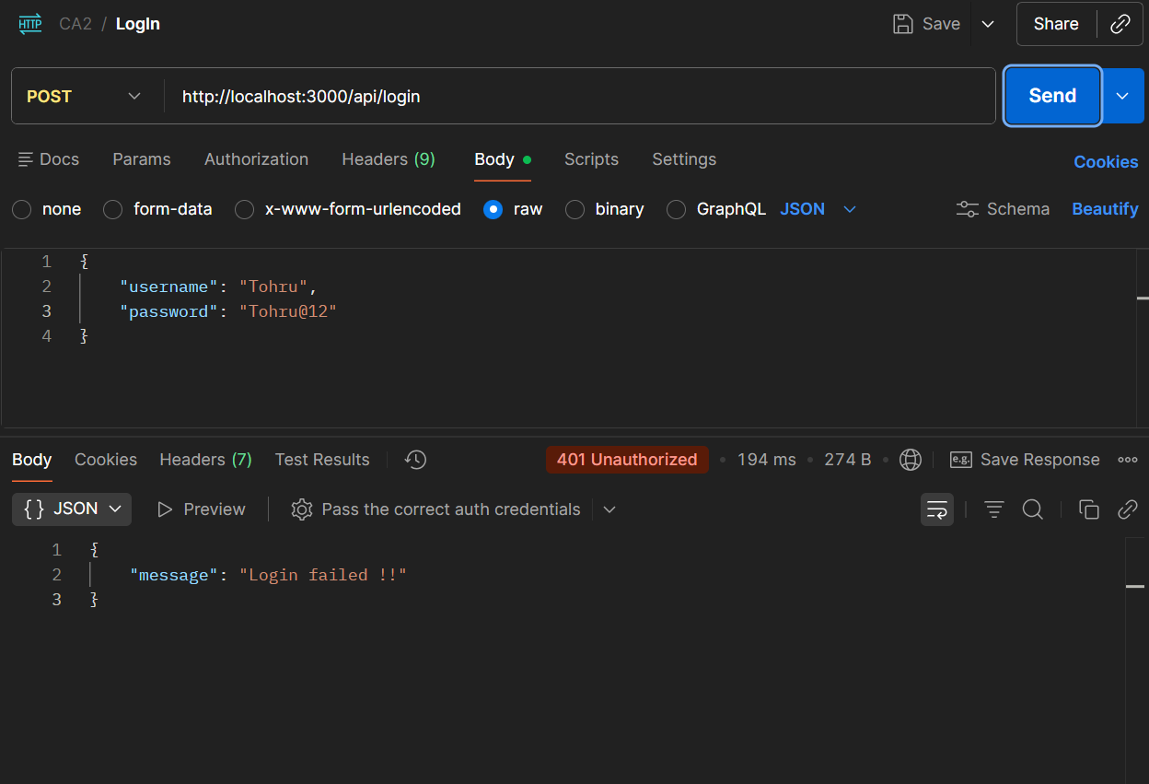
 | POST/api/register | 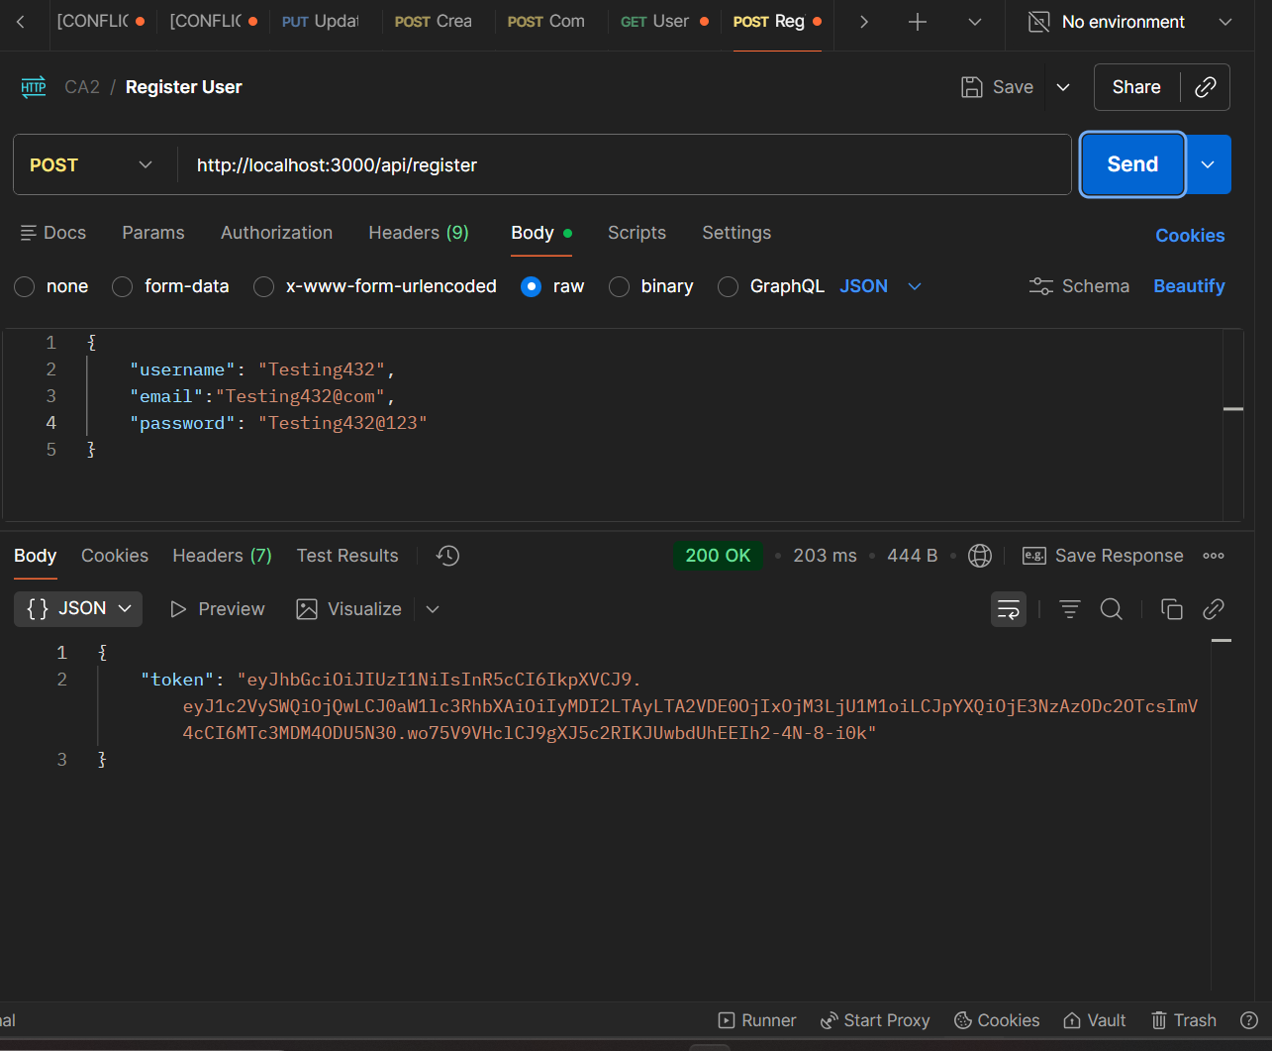
 | POST/api/register | 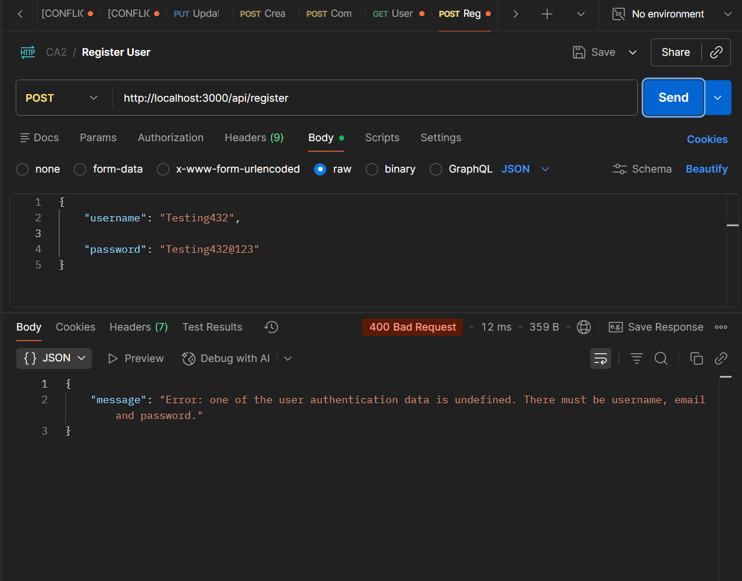
 | POST/api/register | 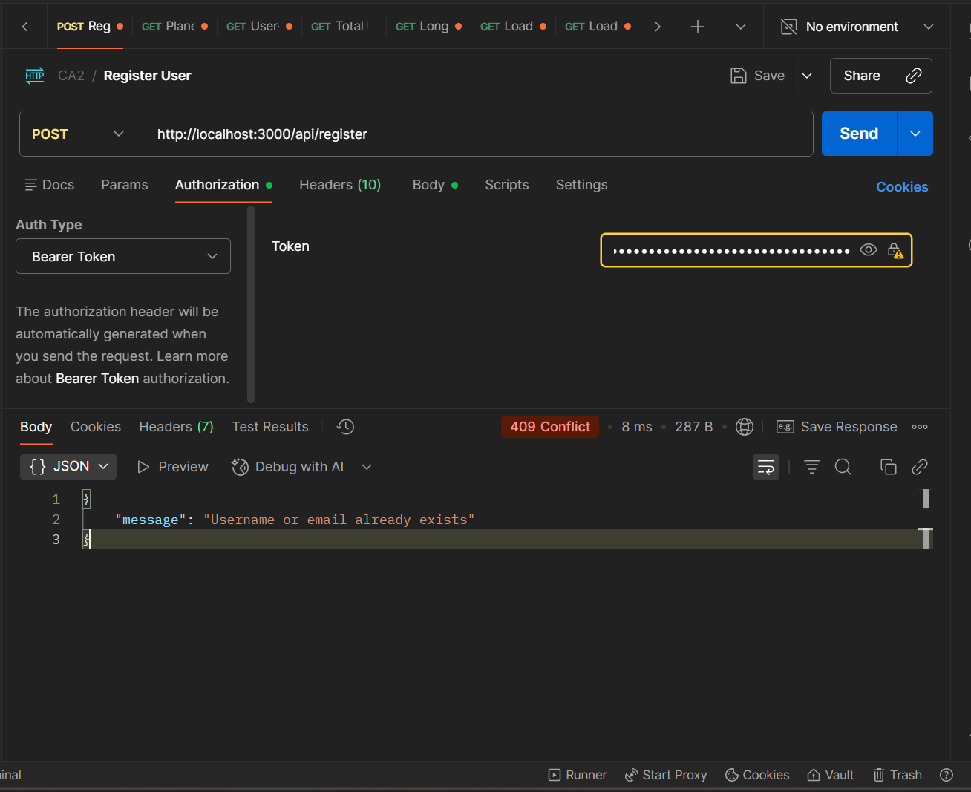
 | GET/api/users/token/profile | 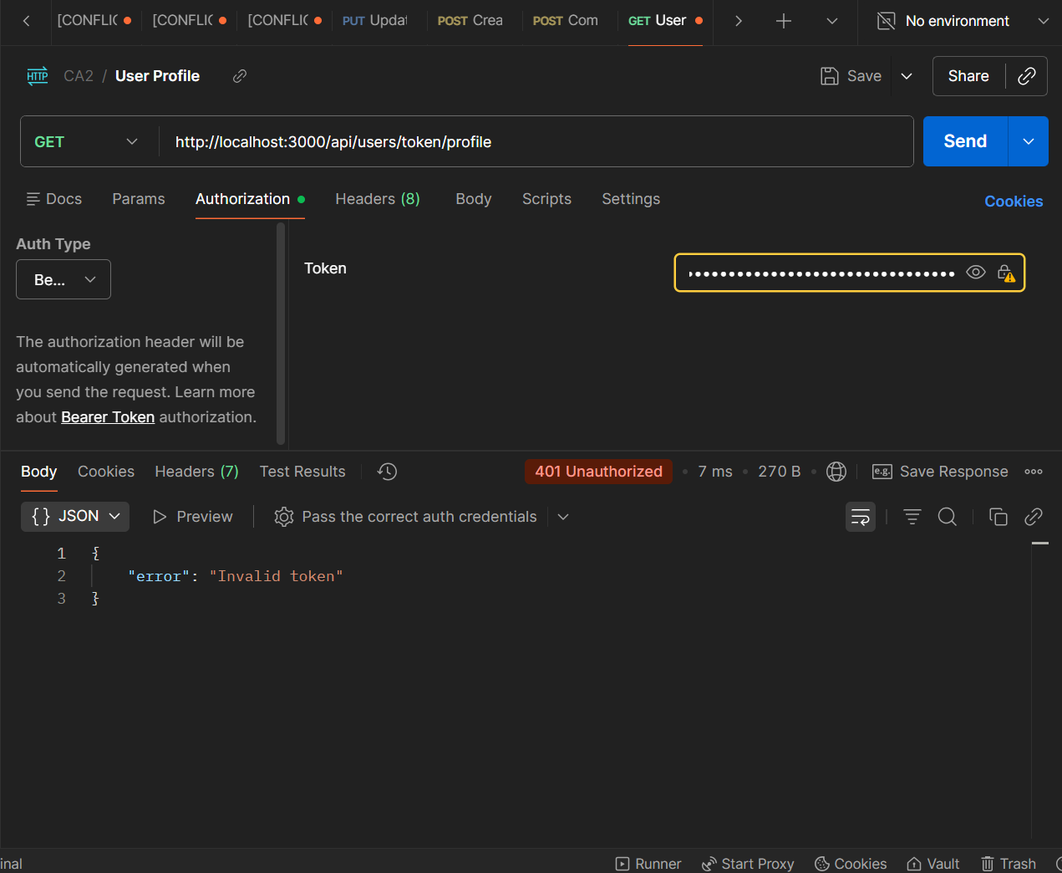
 | GET/api/users/token/profile | 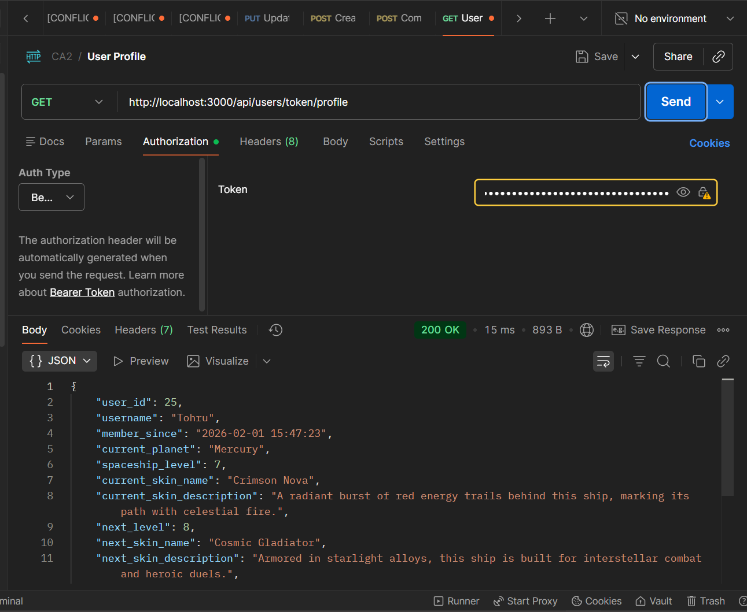
 | GET/api/planets/user/status | 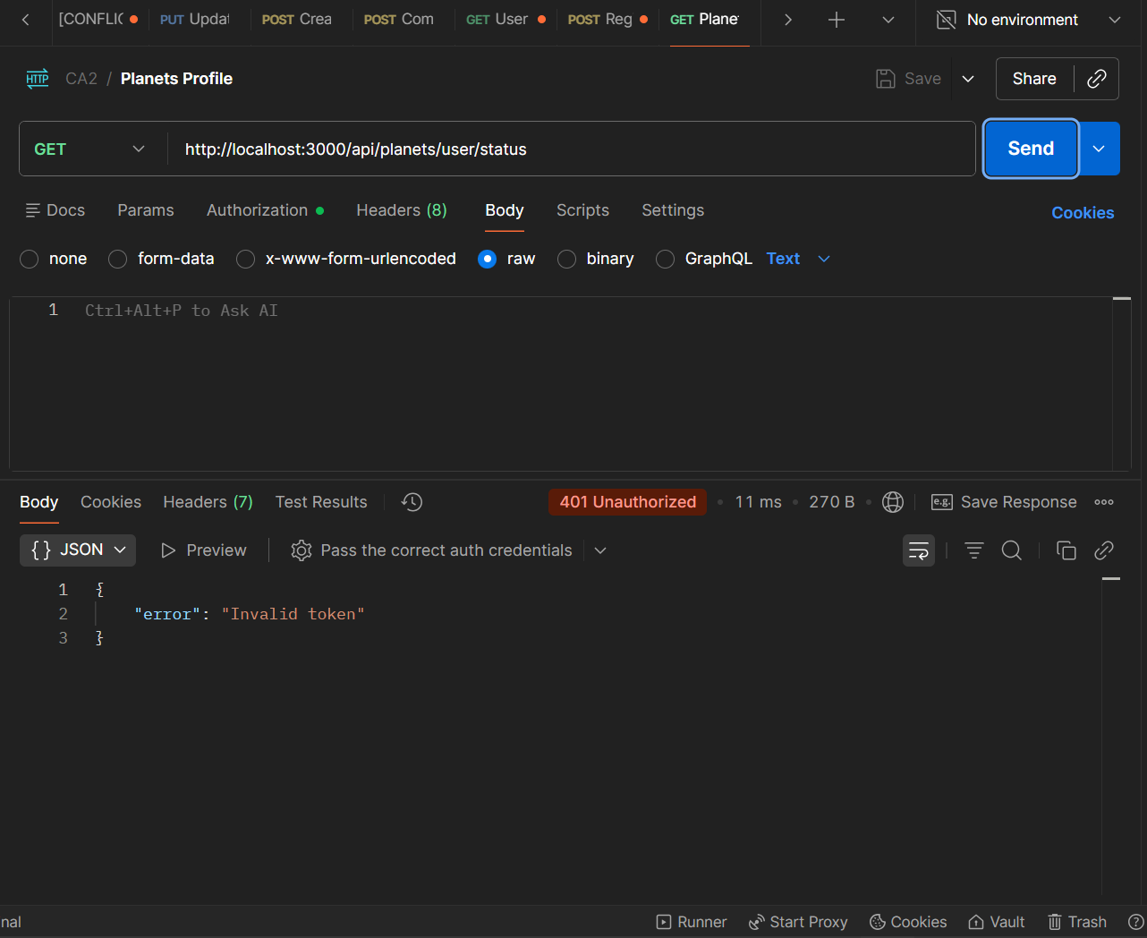
 | GET/api/planets/user/status | 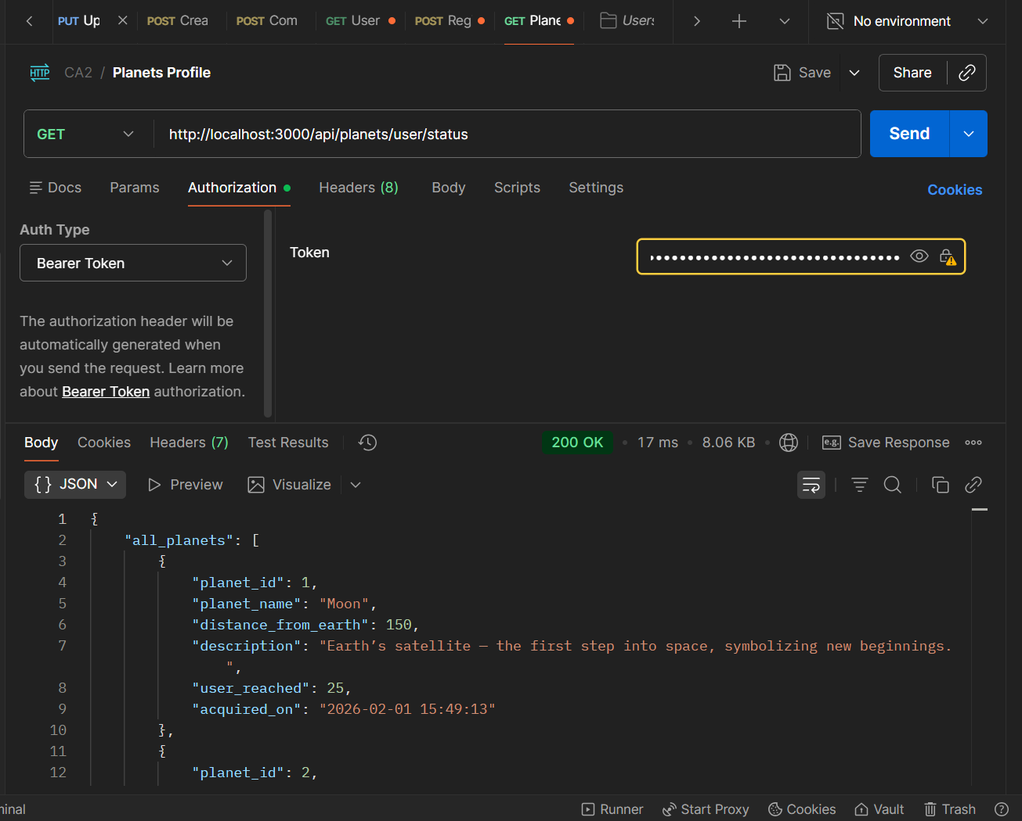
 | GET/api/planets/users/created | 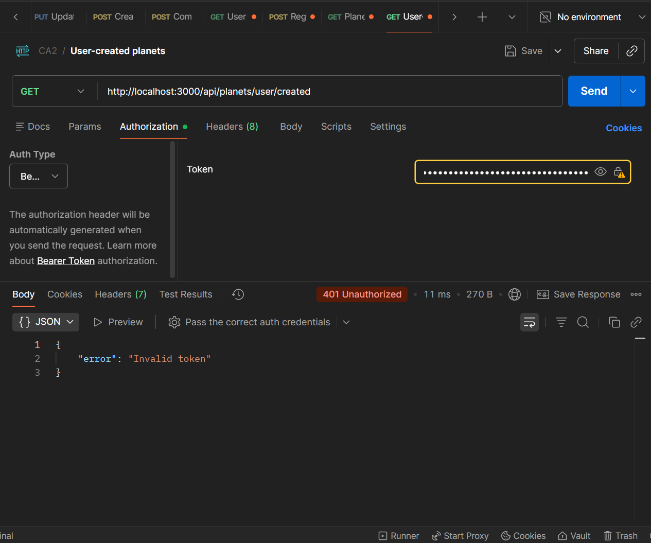
 | GET/api/planets/users/created | 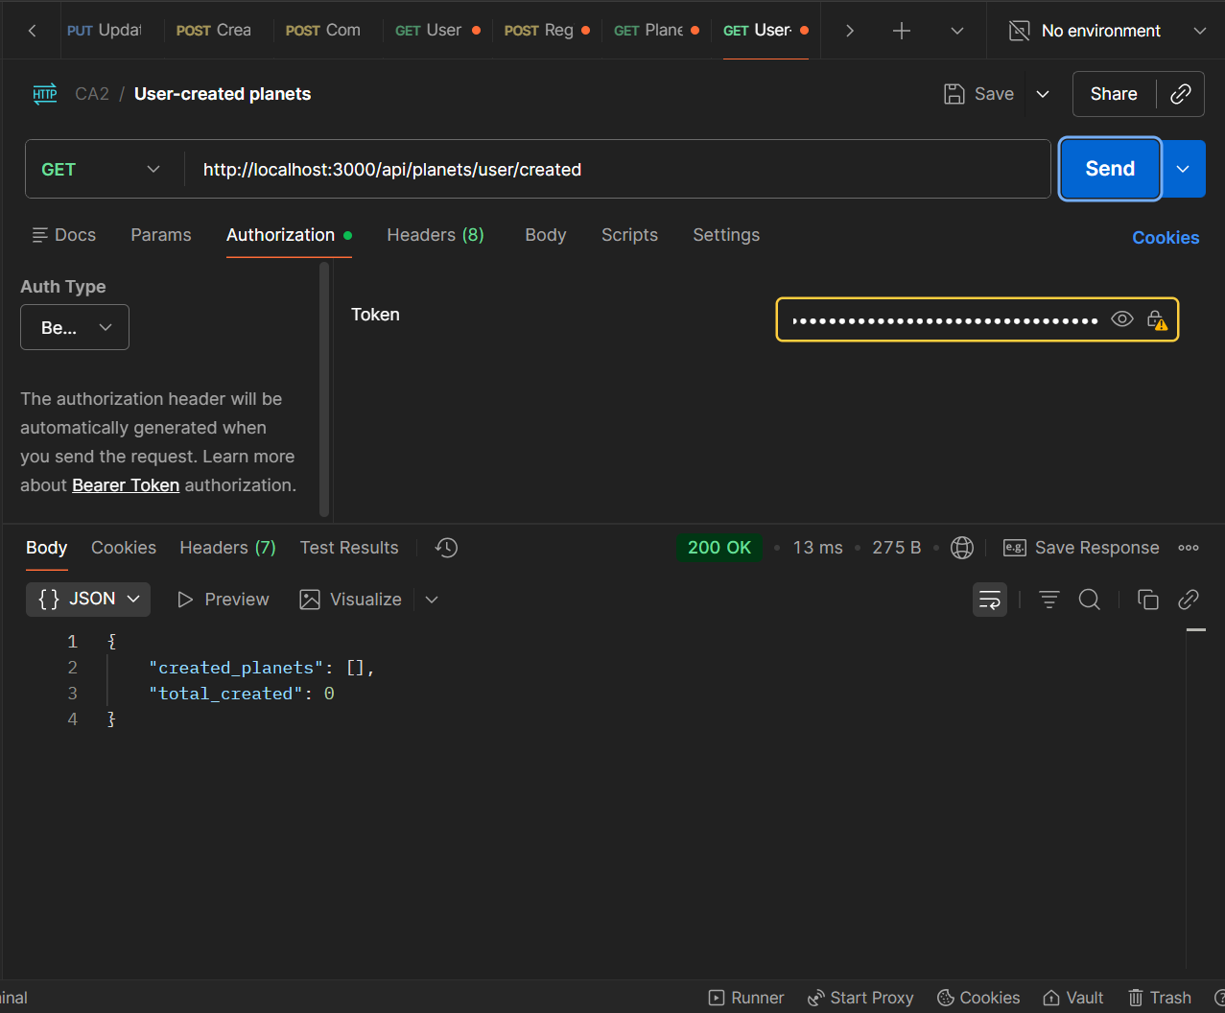
 | GET/api/users/stats/total | 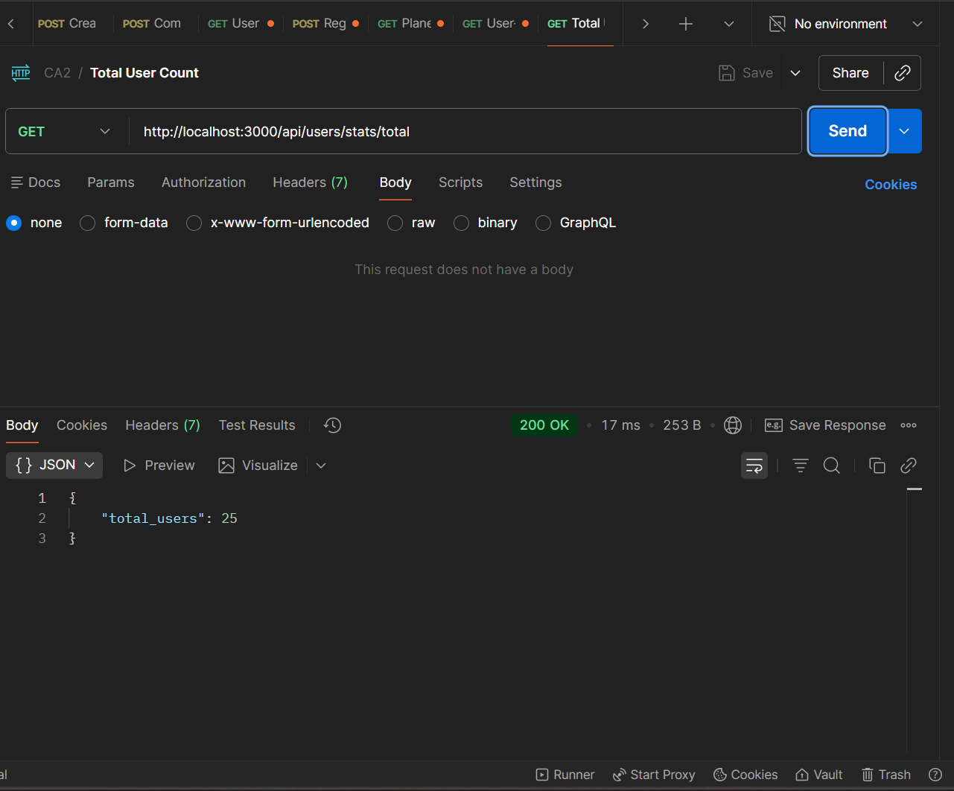
 | GET/api/users/stats/leaderboard | 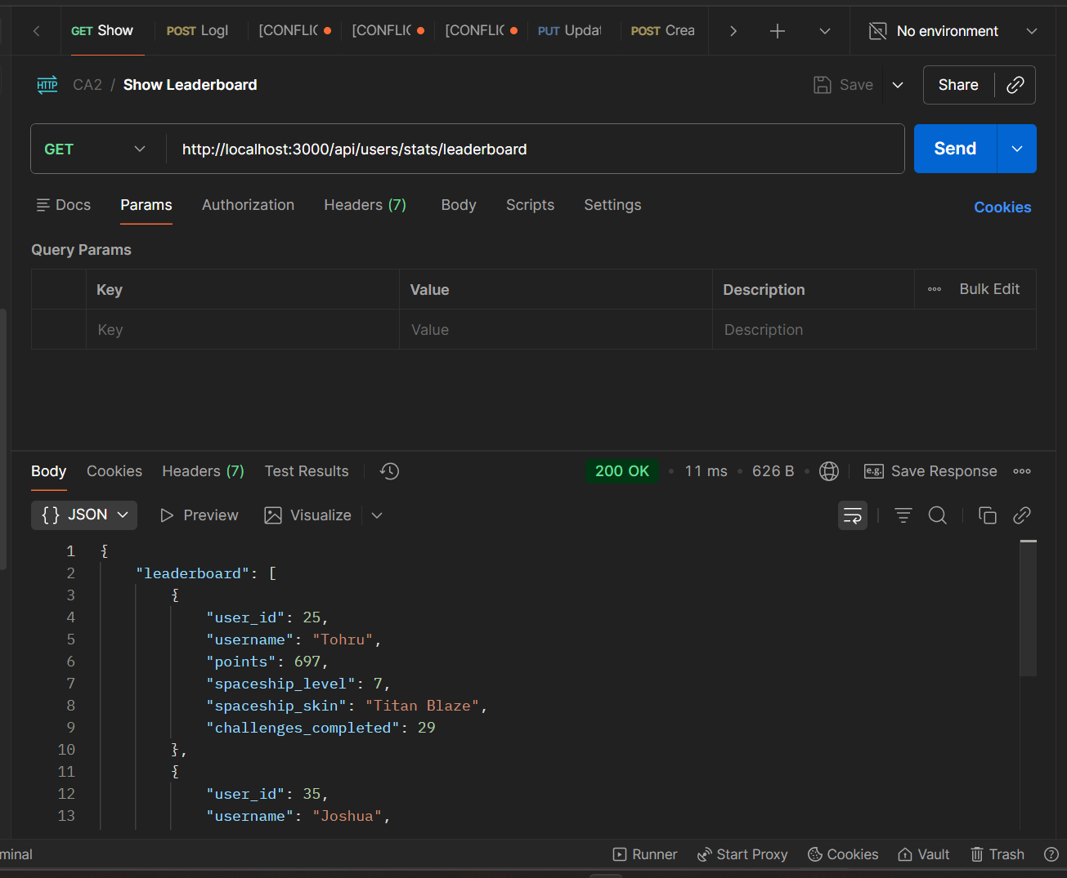
 | GET/api/planets/max-distance | 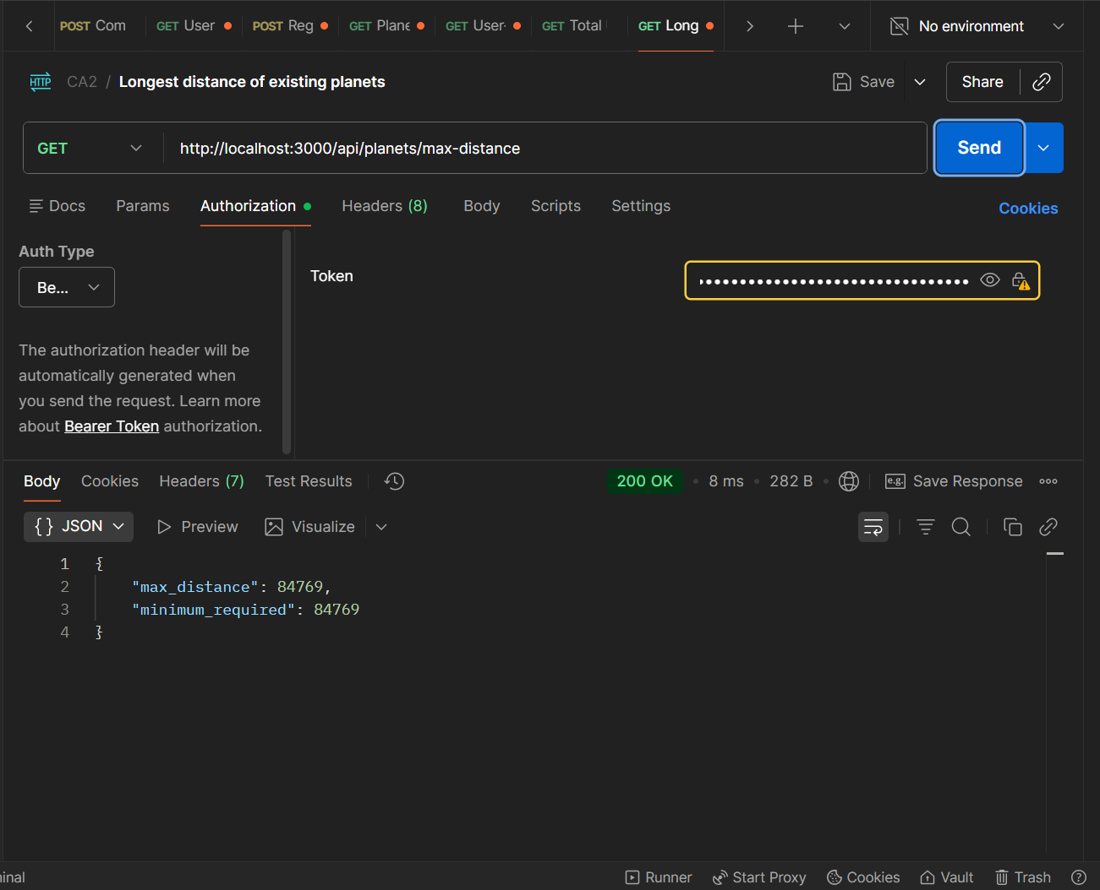
 | GET/api/spaceshipskins/user/status | 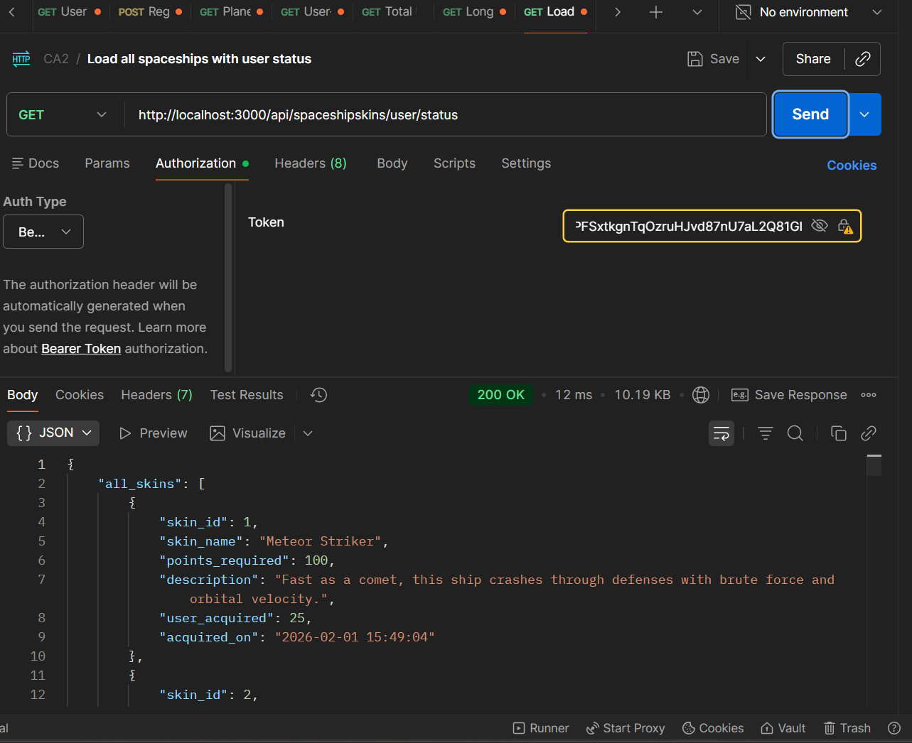
 | GET/api/spaceshipskins/user/status | 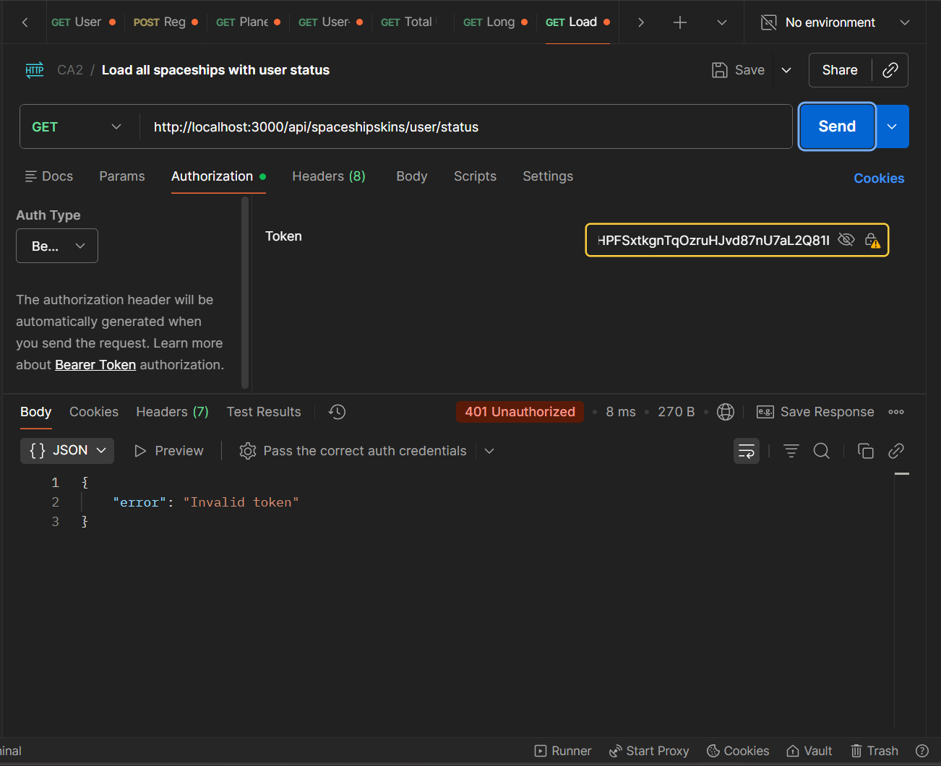
 | GET/api/spaceshipskins/user/created | 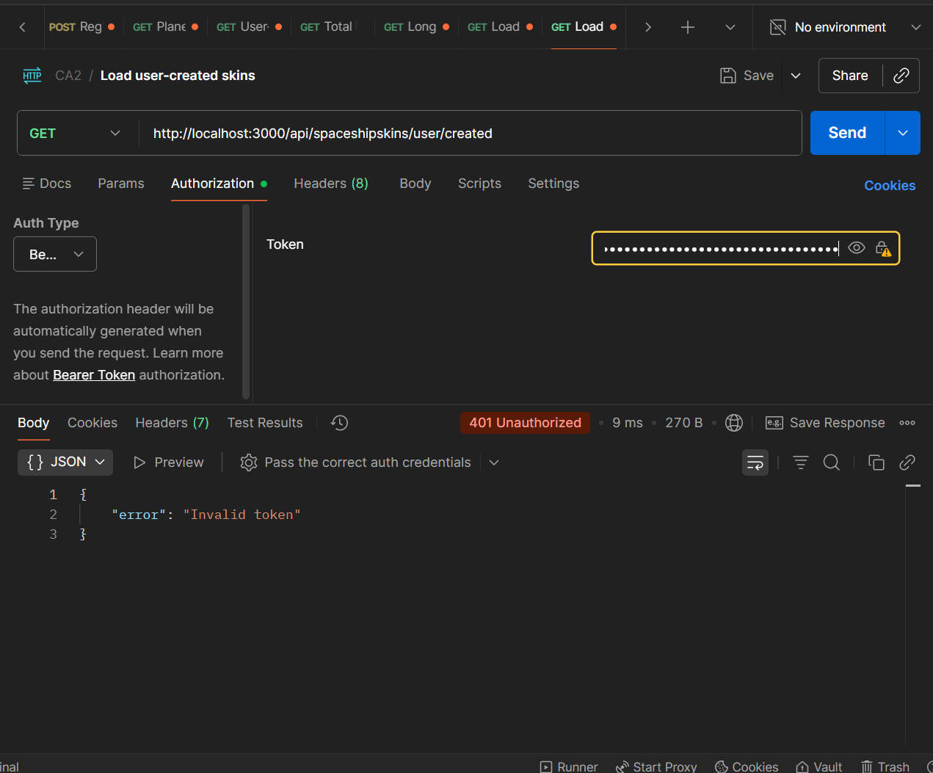
 | GET/api/spaceshipskins/user/created | 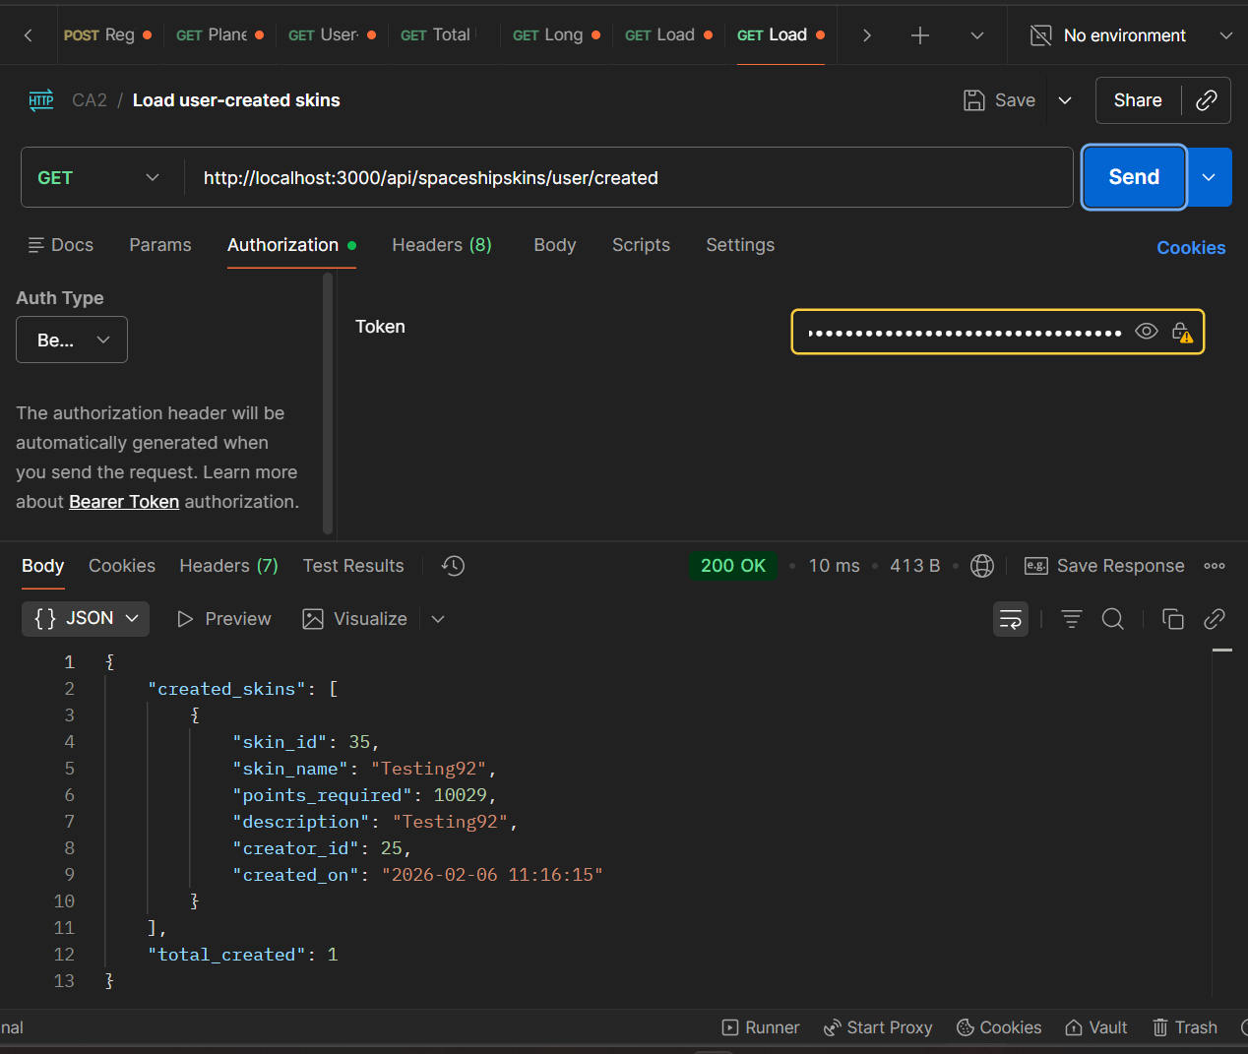
 | PUT/api/spaceshipskins/skinId | 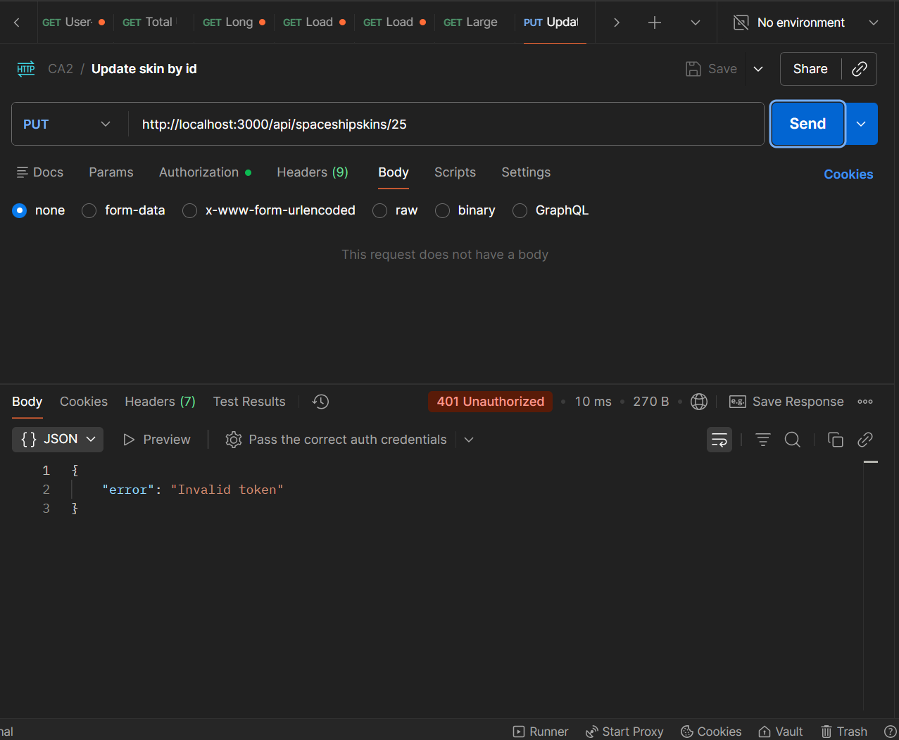
 | PUT/api/spaceshipskins/25 | 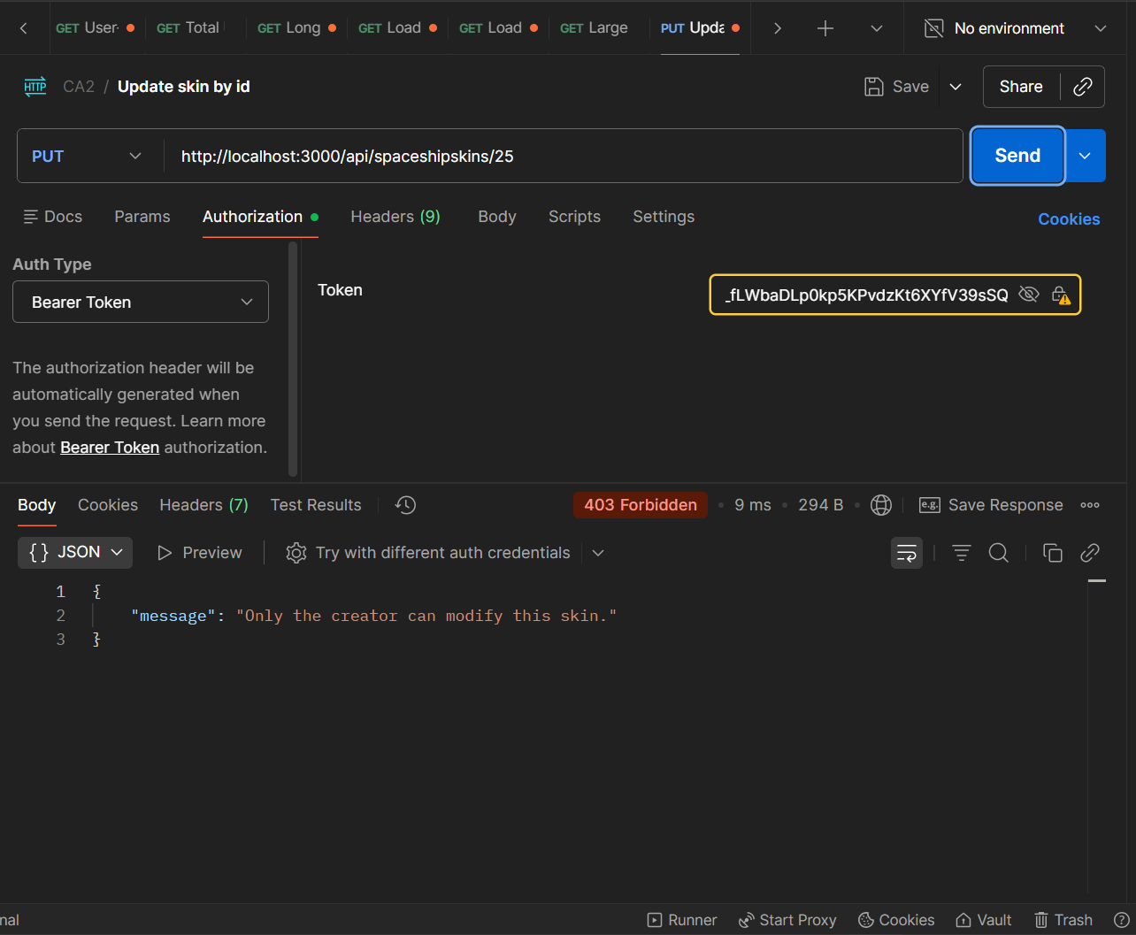
 | PUT/api/spaceshipskins/35 | 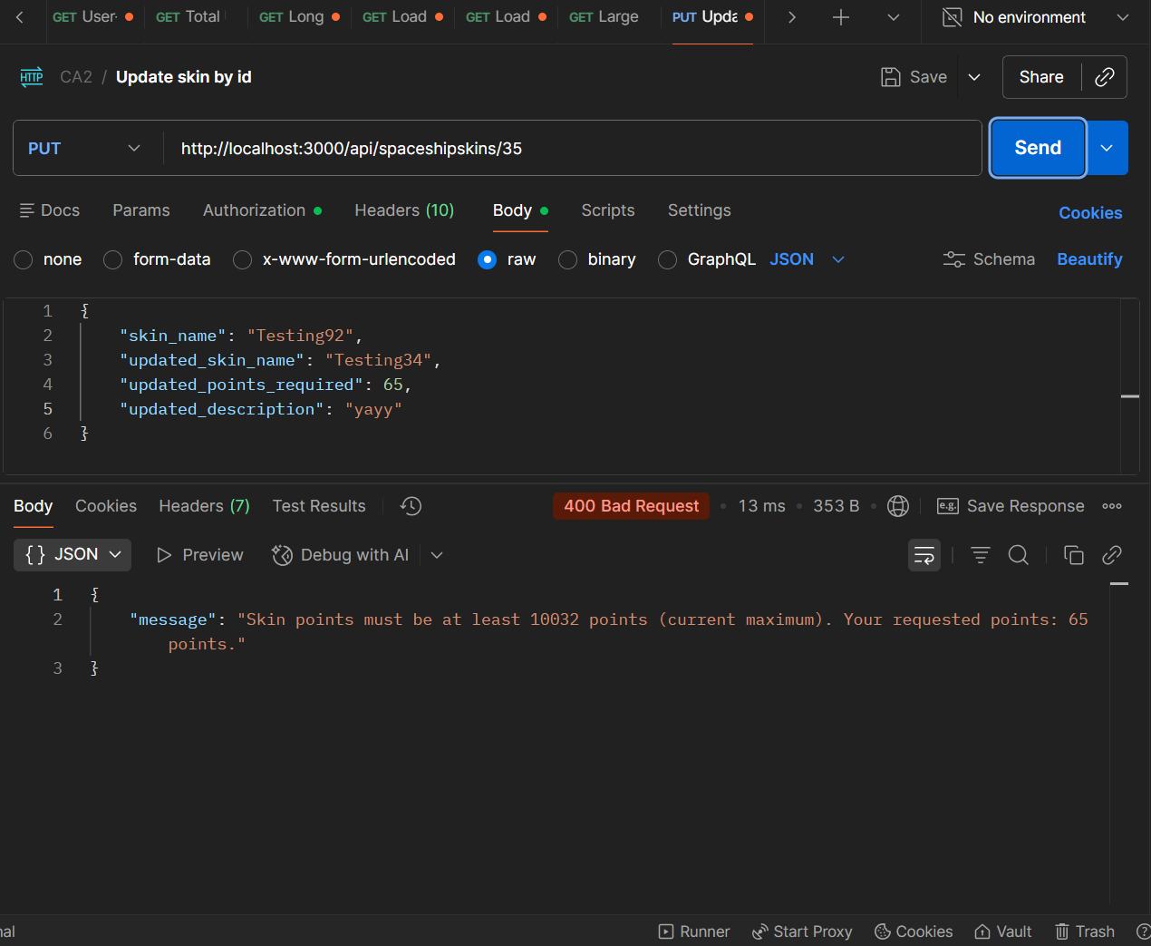
 | PUT/api/spaceshipskins/35 | 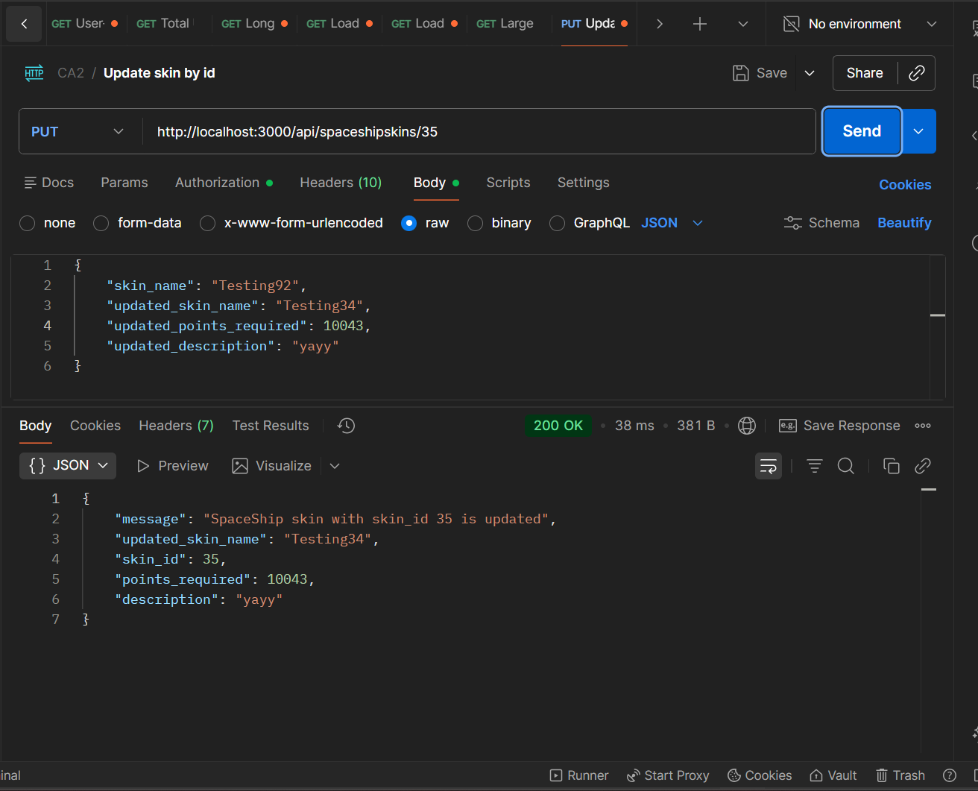
 | POST/api/spaceshipskins | 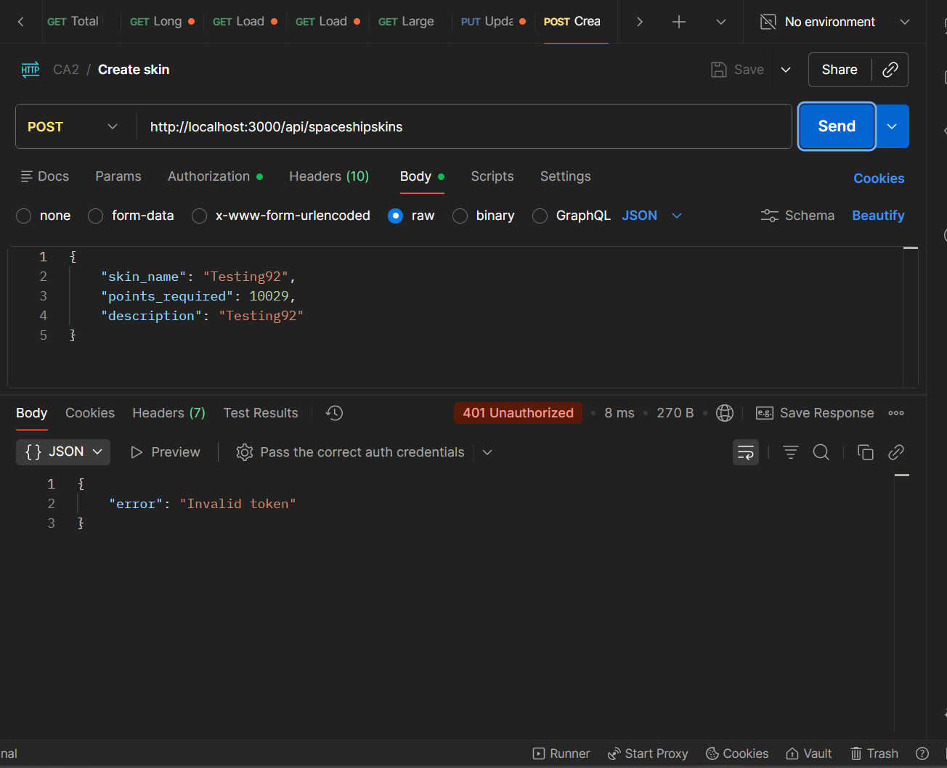
 | POST/api/spaceshipskins | 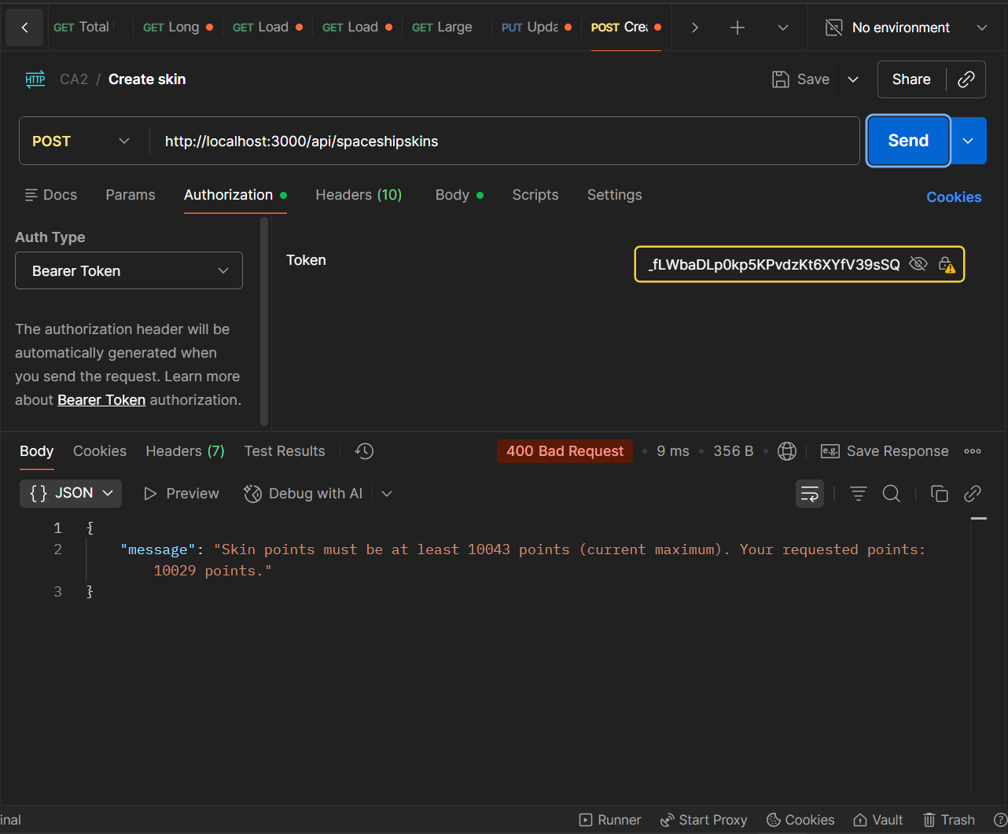
 | POST/api/spaceshipskins | 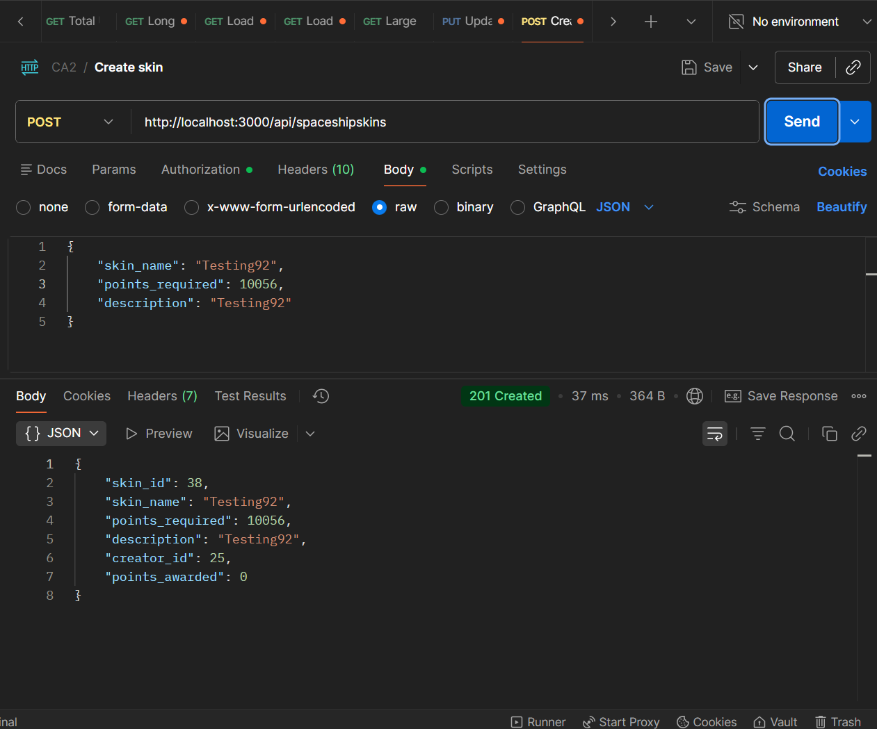
 | GET/api/challenges/user/created | 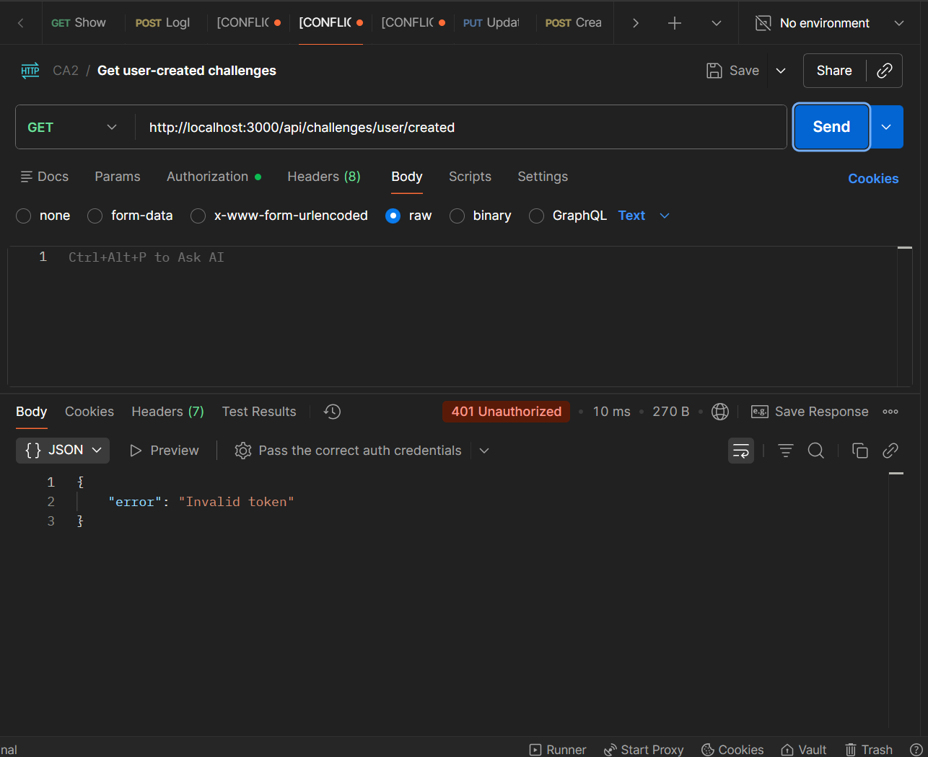
 | GET/api/challenges/user/created | 